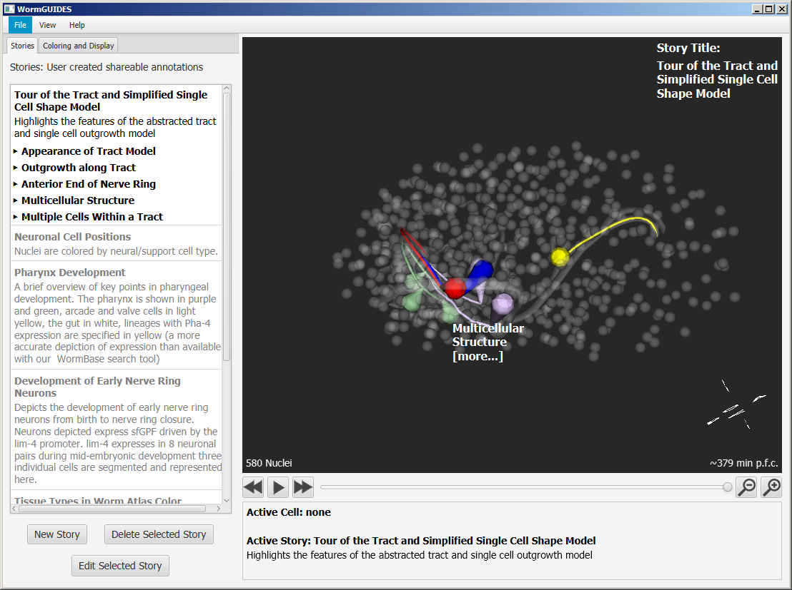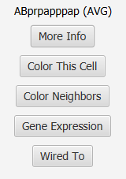**WormGUIDES Intro**

**Intro/Navigation**

**3D window**

The 3D window displays the 4D embryo model which consists of nuclear positions (displayed as spheres) and cell bodies (abstracted reconstructions of individual cells and the outgrowth of their processes). Coloring rules set colors for objects based on various cell properties. Default rules highlight the cell shapes present in the application. Objects not highlighted by coloring rules appear drawn in semi-transparent gray.

Hover over cells (spheres or segmented objects) to see a transient name display.

Click to see permanent name display and make a cell the active cell (the active cell has its name in yellow and its information is displayed in the info pane below the 3D window)

Right click brings up a context menu in which you can with one click create a coloring rule which changes the color of a cell its wiring partners or its neighbors.

* **More Info** brings up the information page for the cell
* **Color This Cell** creates a coloring rule for the cell and pops up the rule editor so colors and ancestry settings can be adjusted.
* **Color Neighbors** colors all cells that are within 1.5 times the distance to the cell’s nearest neighbor at any point in time.
* **Gene Expression** retrieves Wormbase records of genes expressed in that cell (including adult expression patterns). Selecting a gene from the drop-down menu creates an expression coloring rule for that gene. Expression rules effect only embryonic systematic names appearing in the Wormbase expression data (e.g. ABprpapppap is used, AVG is ignored) -so a selected gene will not necessarily color anything (even the originating cell). A web connection is necessary for these functions, and retrieval of queried information takes a few seconds. The message Loading… will be displayed while information is being retrieved.
* **Wired To** provides a hierarchical list of wiring partners arranged by type, selecting **Color All** at any level will create a coloring rule effecting partners at that level.

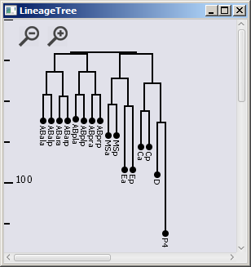**Tree Window**The tree window provides a Sulston-style cell lineage. Clicking on a cell expands the subtree rooted in that cell (or collapses it if expanded) as well as navigating to that cell in the 3D window. The icons on the upper left allow zooming in and out, the tree can be navigated using the scroll bars or by clicking and dragging.

Tree coloring matches the 3D window. Right click in tree window behaves the same as the 3D window.

**Info Window**

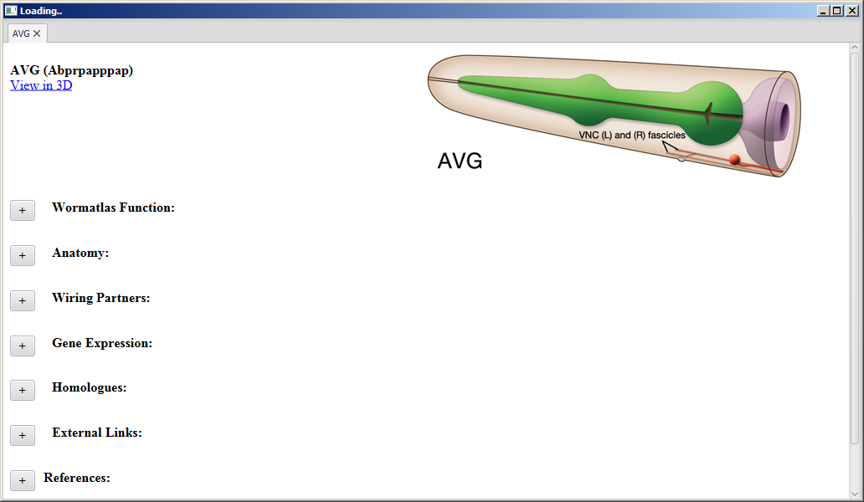Right clicking and choosing “**More Info**” or clicking ‘**[more info]** ‘ for the active cell description in the info panel launches an info window with a summary of information about that particular cell. The information window is populated by querying internal and web sources. It may take a few seconds for a page to load information from the web. Click on the + button by any entry to expand it . Information unique to the desktop WormGUIDES includes **Anatomy**, which provides a detailed anatomical classification per cell (currently available only for some neurons) and **Primary Data** which details the data sets on which app geometry are based. Information includes cell drawing, wiring partners and Wormatlas cell function summary for neurons. Expressed genes returned from Wormbase anatomy search, references from Textpresso and links to source documents and other relevant websites and searches are also included.

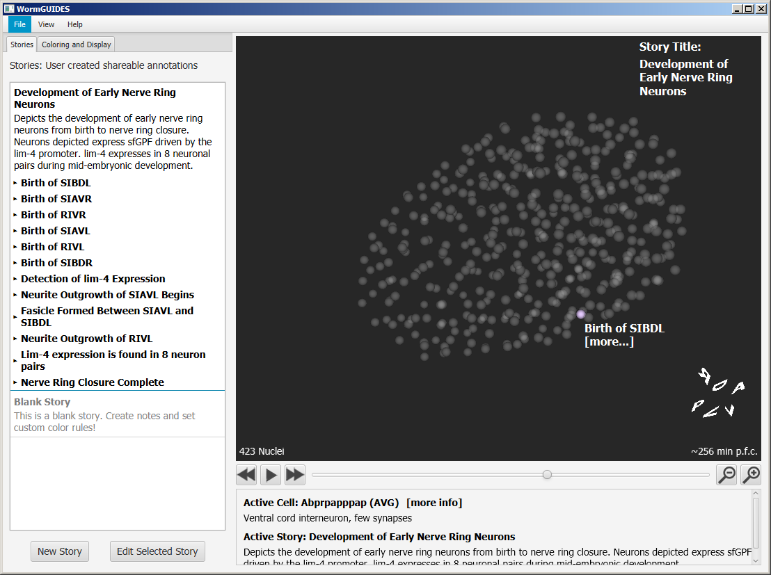**Stories tab and Story/Note Editing Window**The stories tab allows you to display previously annotated developmental events for the embryo in the 3D window in the form of notes arranged in stories.

**Viewing a story:**

A story comprises of a series of notes. Each note is an annotation (of a cell, event, etc.) at a particular time range and at a particular point in 3D space. Clicking on a story title will make the story active and make the notes in the story visible as well. It will also make the color scheme associated with the story the current color scheme. Clicking on a note will bring you to the (first) location of that note in 4D in the model. Clicking on the note in the 3D window or the expand triangle next to the note name in the Stories pane will display the full text of the note.

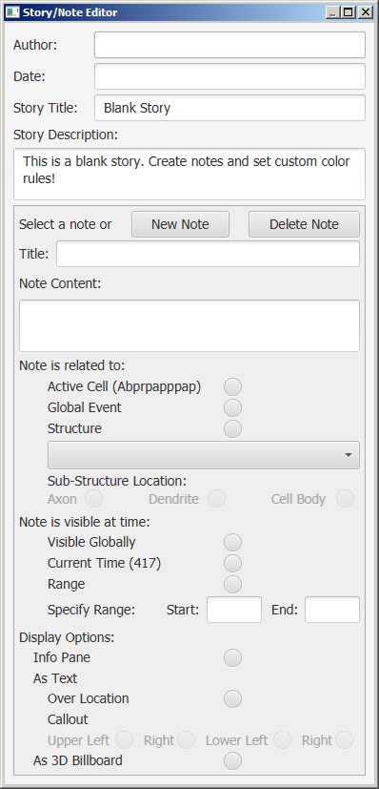**Editing/creating a story**   
Users can create new stories or new notes in exiting stories in order to record their observations and share them with others.

Clicking the **Edit Selected Story/New Story** button will launch the Story/Note editor that allows you to create new notes attached to the locations of cells or structures. (Click new note and enter contents. All edits become part of the current active story within the app. To save stories for future use or to share them with others choose File->Save Current Story. This saves the currently active story to a csv file that records story/notes content story color scheme and model view. A saved story can be loaded by choosing File->Load Story, the loaded story is added to the story list in the app.]

A note has a title (which is displayed in 3D window) and content which is displayed when the note is clicked. A note is attached to a point in space (the active cell, or a multicellular structure selected from the list), or can also be unattached and global.

A note is also attached to a range in time (which can be entered) or a single time point (specified as the current time after navigating to that time point in the 3D window).

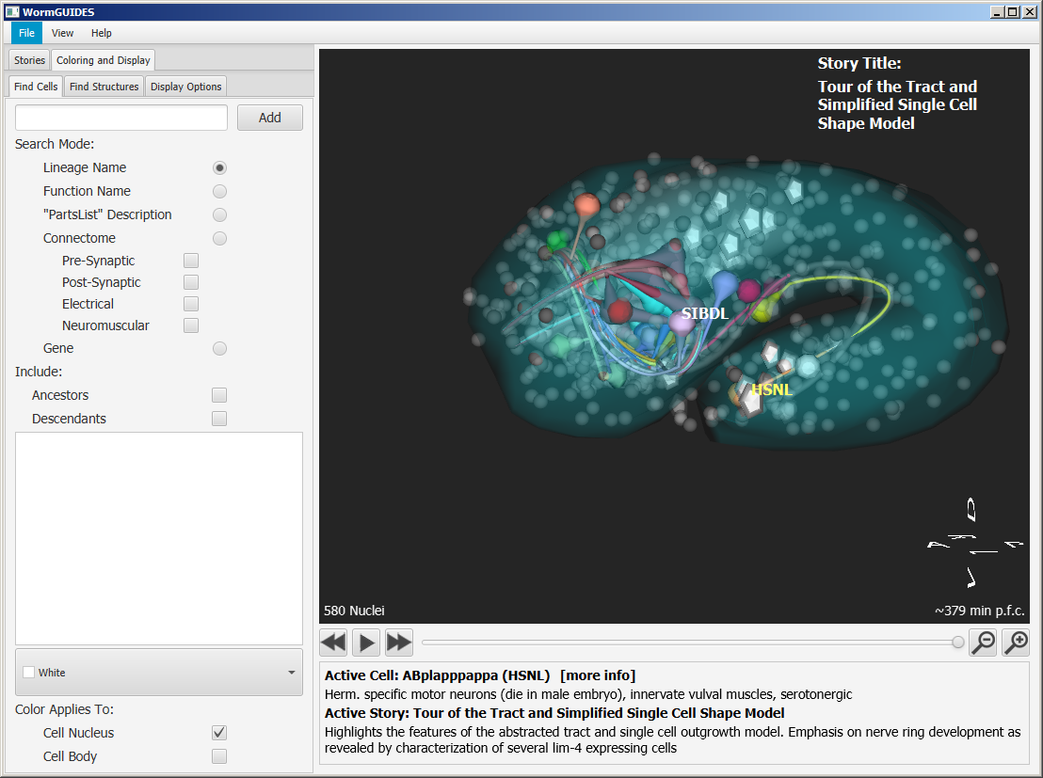**Coloring and Display**  
Coloring and display consists of 3 sub-tabs

**Find Cells** allows you to create a number of types of cell searches. Each returns a list of cells that will be displayed in the 3D window and will receive a selected color. A keyword is entered, a color selected, the results can be previewed (they are highlighted in yellow in the 3D window and listed in the preview pane). Tick boxes control whether the rule affects the nucleus or cell body or both as well as if it also effects the descendants or ancestors of the cell. Once settings are made the rule is created by clicking add.

The desired search type must be selected from the list of radio buttons. The search can be made using a cell’s functional name, (e.g., AIYR) or lineage name (e.g., ABprpapaaap for AIYR, this is the default mode). **“Parts List” Description** searches for the entered key word in the text describing cell functions. The **Connectome** mode searches for cells wired to a cell entered in search. Connectivity types checked will be included**.** The **Gene** mode searches Wormbase for the entered gene and returns a list of the cell systematic names (e.g. ABalaaaa) which are found in the resulting webpage. (This requires web access).

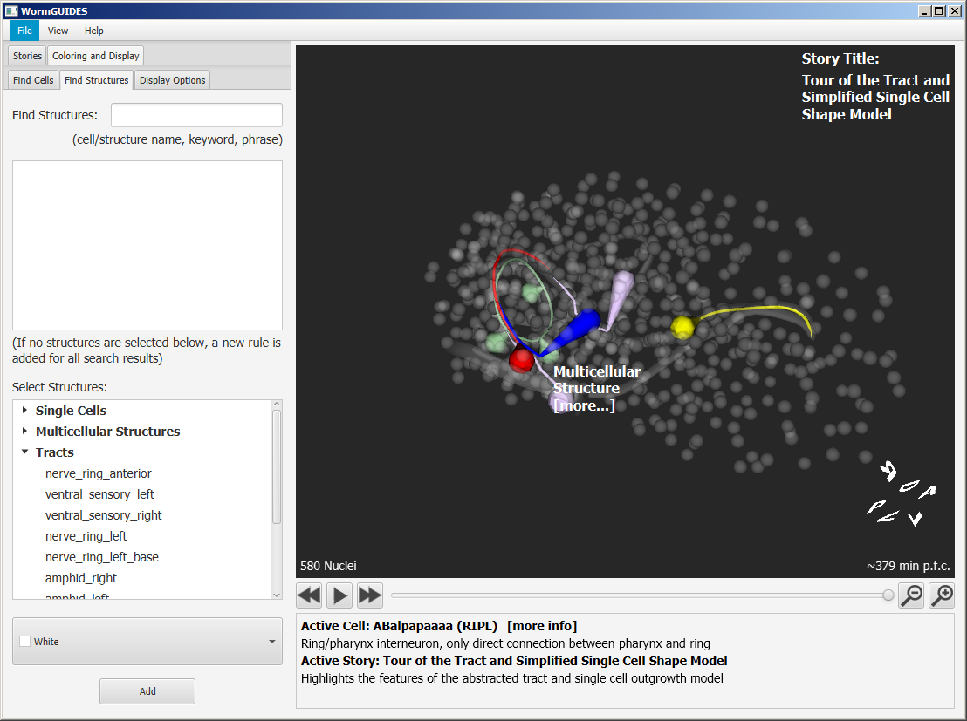The **Find Structures** tab allows you to search or select segmented structures. A cell name or name/description text can be entered. A list of structures is generated and a single coloring rule is created for all structures when the add button is clicked. Alternatively a structure can be selected from the list in the lower part of the panel and will be added when add is clicked. This list is hierarchical, headers can be expanded to show individual elements. Selecting a header and clicking add creates a single rule that applies to all structures under the header.

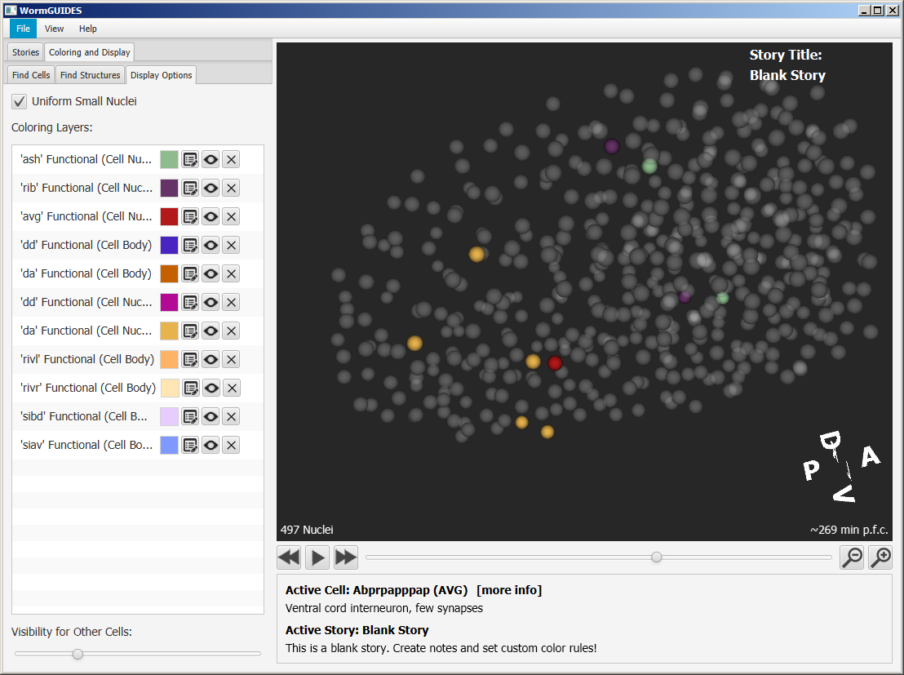

**Display Options**   
A list of all default and user-added coloring rules is displayed. These can be removed (with the X button), temporarily hidden (with the eye button) or edited. The list also serves as a color key.

**File Menu**

**File  
Save Active Story** saves the current story and notes along with associated color scheme (this saves all color rules both those supported and unsupported by the mobile version of the app).   
**Load Story** loads a previously saved story.   
**Capture Video** will save the playing embryo model as a movie.  
**Save Image** saves the current frame as an image (note these views currently omit labels).  
**Share Scene** encodes the current scene (color rules and orientation) in a URL that can be shared with others by pasting it into an email. Note this URL implements only the rules compatible with the mobile app. This allows compatible coloring schemes to be shared between the desktop and mobile app.  
**Load Scene** allows you to paste a URL into the app to regenerate a previous view.  
**Save Search Results** saves the cell list from a search as a text file of names

**View**Commands to launch additional windows

**Lineage Tree:** launches the interactive lineage tree

**Primary Data:** Primary data launches table views of all cell information documents underlying the app.

**Cell Info Window:** launchesan info window with a summary of information about a particular cell from internal and web sources.

**Rotation Control:** launches a manual rotation control that helps achieve precise orientations.

**Help**

Info about the app

For further assistance contact support@wormguides.org